River Schenck

Chibuike Chikere-Njoku

Skyler Judson

HW 12

expl10.1 (read-only)

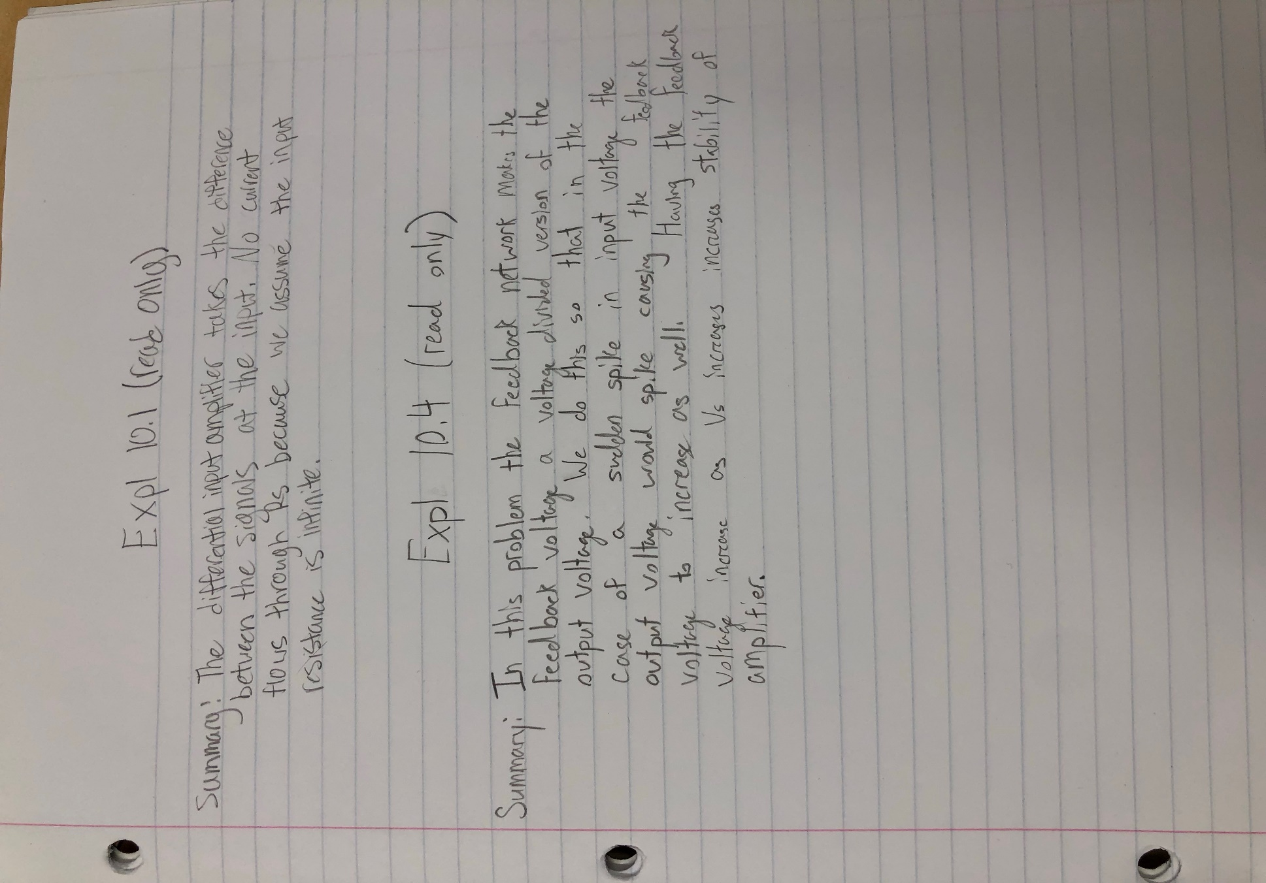

p10.1: Feedback gain

p10.11: Gain desensitivity

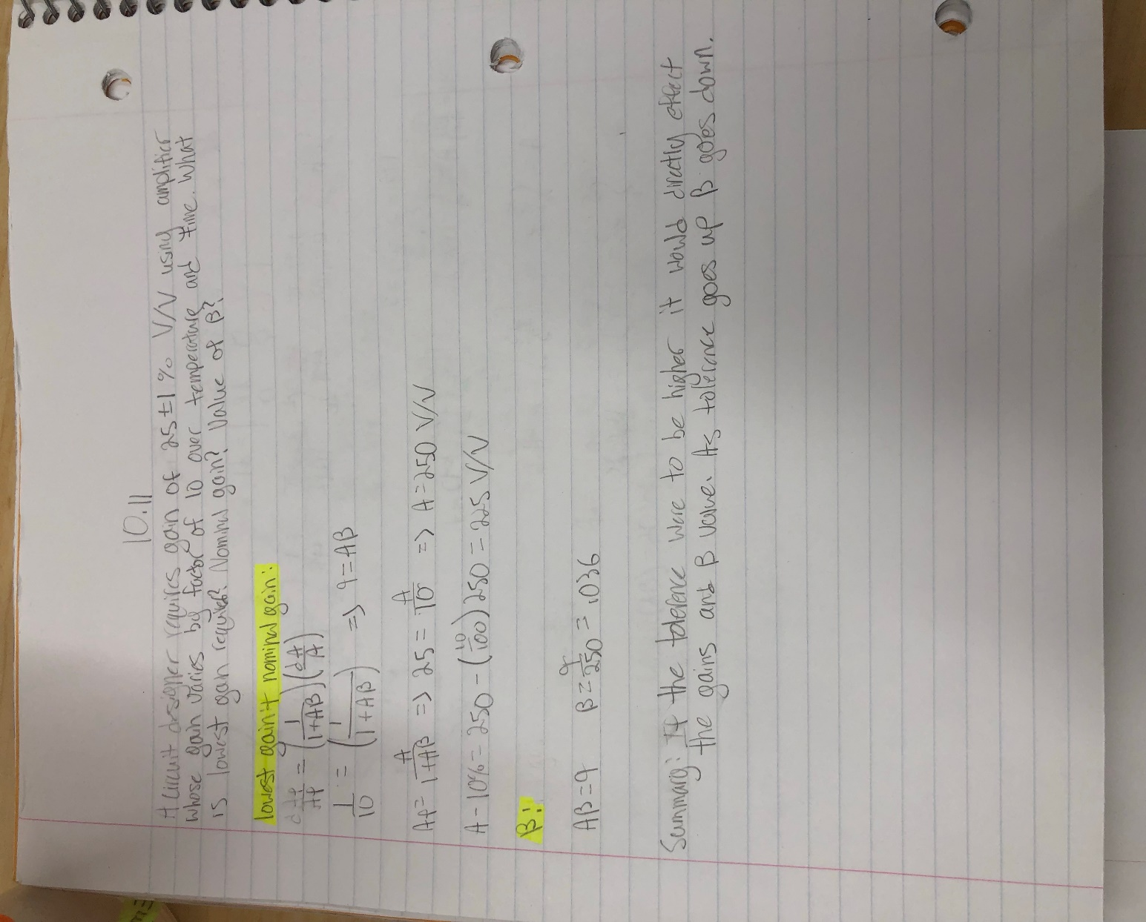

p10.16: Bandwidth extension

